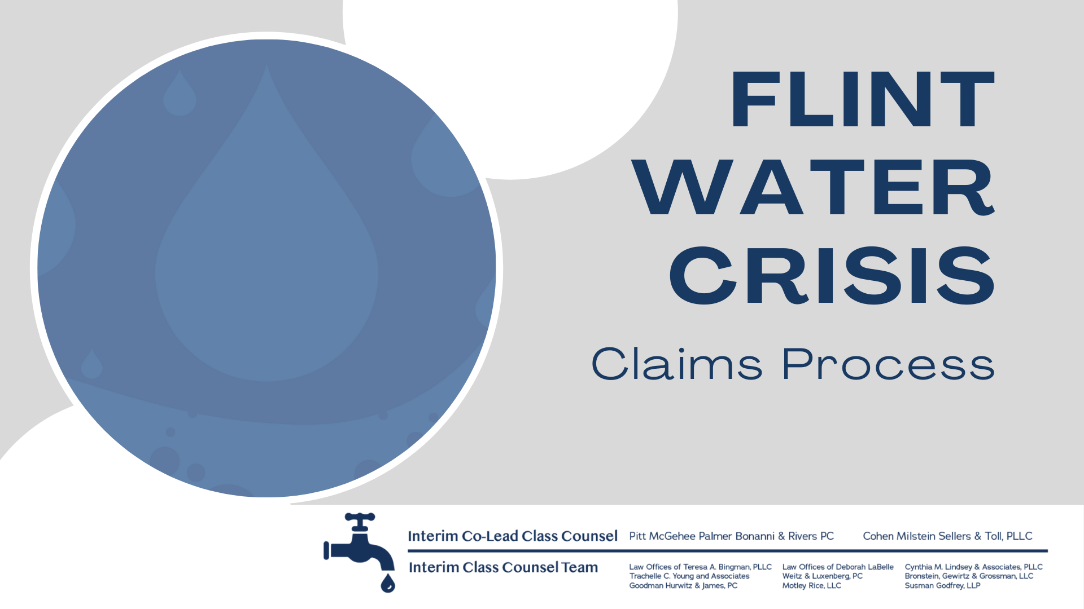

The Interim Class Counsel Team presents this packet of instructions for completing the Flint Water Crisis Settlement Claims Forms and process.

Included:

- Checklist
- Samples of the Claims form
- Guidance for Determining Your Categories
- Declarations
- Release Form
- Lien Disclosure Form
- Supporting Documents

We are here to help. Please reach out to us.

Phone: 866-536-0717

Email: info@flintwaterjustice.com

Fax: 248-268-7996

If you would like one-on-one, personalized help, please make an appointment to visit our Flint office by calling or at our website:
www.Flintwaterjustice.com

Claims Process Checklist

Claims Form (signed or e-signed)

Declaration(s) (signed or e-signed)

  - Complete one Declaration of Exposure for each claim form where any of the categories between 1-27 were selected.

  - Complete a Declaration of Real Property Owner/Renter and/or Business Owner where any of the categories between 28-30 were selected on the claim form. Complete one form per Flint residential or business address.

  - Complete a Business Interruption Claim Form where any of the categories between 29-30 were selected on the claim form. Complete one form per Flint business address.

Release (signed or e-signed)

Lien Disclosure Form (signed or e-signed)

- Complete one if you:

- Had Medicare C, private policy insurance, or VA or Tricare coverage since April 25, 2014, AND
- Treated with a medical professional for physical injury

Supporting Documents

- Form of identification (ID for adult, birth certificate for minor);
- Documents supporting the category(ies) of harm identified on the Claims Form

PLUS,
- If forms were completed on behalf of someone else, documents that reflect legal authority to do so (ex. birth certificate identifying parent, adoption papers, court document showing appointment of decedent’s estate and death certificate, court order showing appointment as legal guardian);
- If any of categories 1-27 marked on Claims Form, provide Proof of Exposure;
- If a Business Interruption Claim Form completed, tax documents must also be provided.

The Claims Form

Section 1: Claimant Information
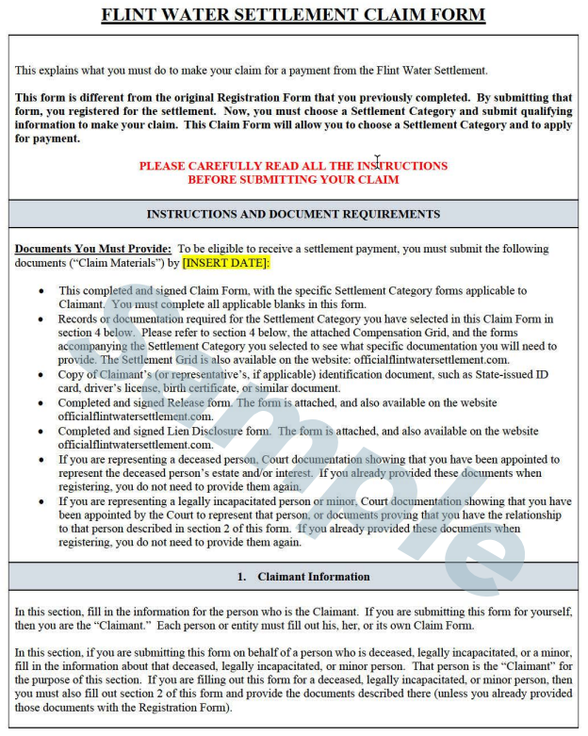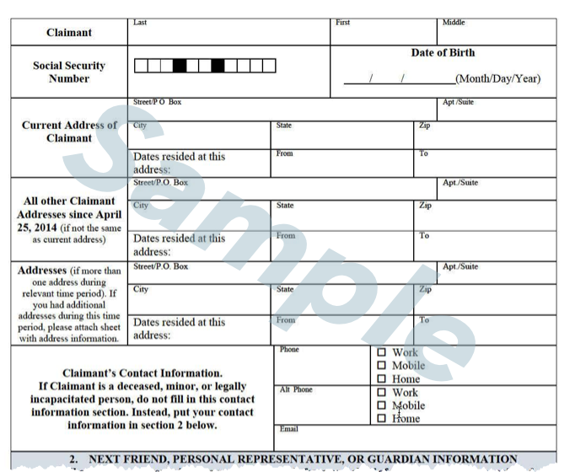
Section 2: Next Friend, Personal Representative, or Guardian Information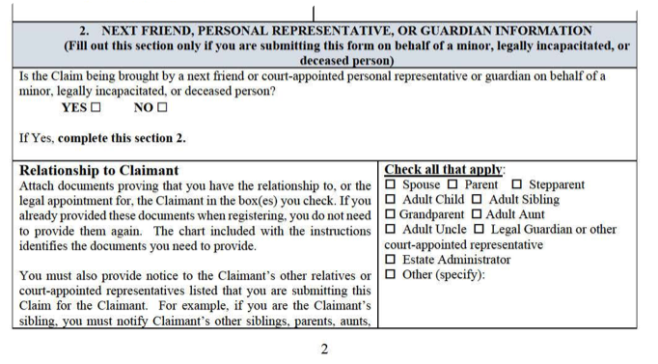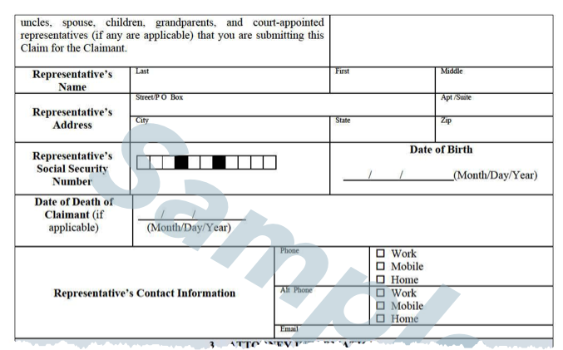

Section 3: Attorney Information
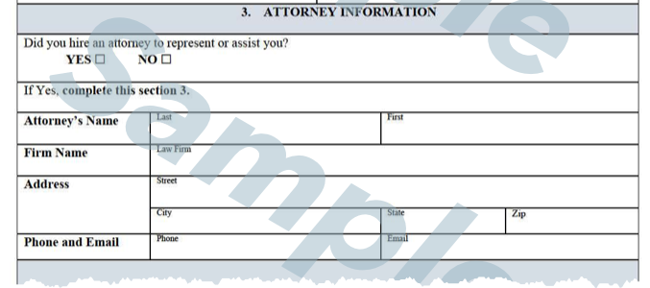

Section 4: Settlement Categories
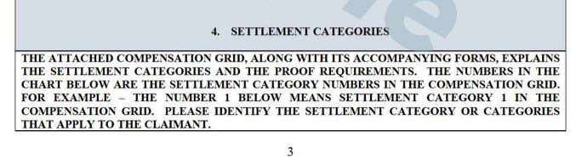
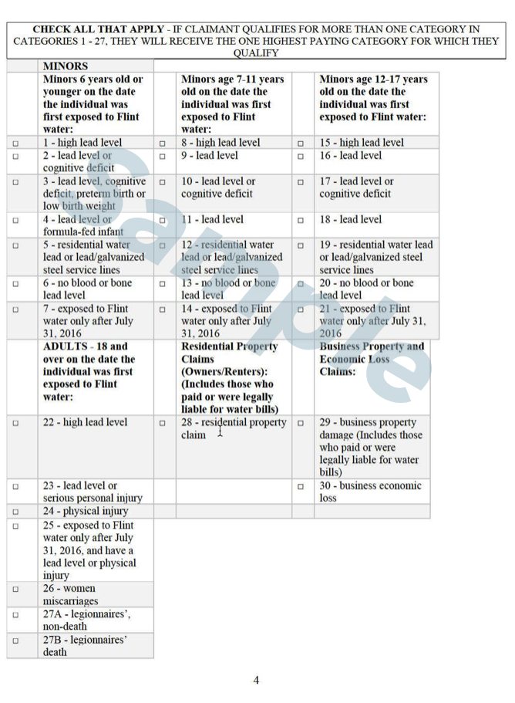

Section 5: Verification
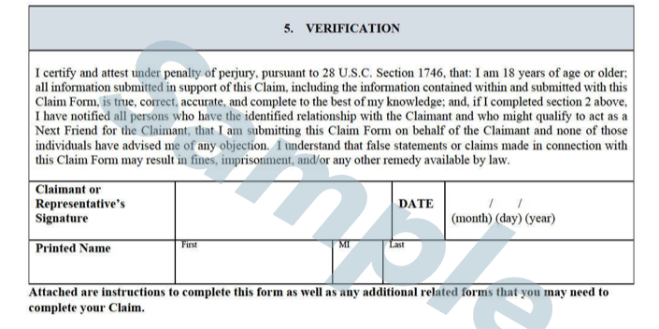

Determining Your Categories
In addition to the Claims Form Instructions, the Interim Class Counsel Legal Team has created this guide to help you select your Settlement Categories.

As an overview, the categories are grouped as shown below:

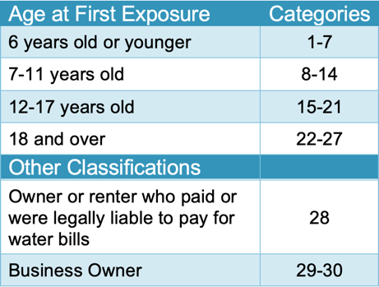

Refer to the tables on the following pages for more details:

- Categories 1-7
- Categories 8-14
- Categories 15-21
- Categories 22-27
- Categories 28-30

If claimant was 6 years or younger when first exposed (categories 1-7)
(select all that apply)
**Categories 1-6 require exposure between April 25, 2014 and July 31, 2016 (at least 21 days out of 30)

Category 1 – high lead level test  Either:  - Blood lead level test of 10mcg/dL or above between May 16, 2014 and August 31, 2016 OR  - Bone lead test of 10.0ug/G or above taken from May 16, 2014 to date  Supporting Documents:  - blood lead test result and/or bone lead test result, as applicable  - proof of exposure (p.10)  - Declaration | Category 2 – lead level or cognitive deficiency  Either:  - Blood lead level test between 5.0 and 9.9mcg/dL taken between May 16, 2014 and August 31, 2016 OR  - Bone lead test between 5.9 and 9.9ug/G taken from May 16, 2014 to date OR  - Cognitive deficiency caused after May 16, 2014 at a development rate of 2.0 standard deviations or more below the mean  Supporting Documents:  - blood lead test result and/or bone lead test result, as applicable OR  - report of a cognitive deficiency  - proof of exposure (p.10)  - Declaration | Category 3 – lead level, cognitive deficit, preterm birth or low birth weight  Either  - Blood lead level test between 3.0 (including results reported as “<3.0”) and 4.9mcg/dL taken between May 16, 2014 and August 31, 2016 OR  - Bone lead test between 3.0 and 4.9ug/G taken from May 16, 2014 to date OR  - Cognitive deficiency caused after May 16, 2014 at a development rate of 1.0 standard deviations or more below the mean OR  - Infant born preterm or low birth weight PLUS  - Mother was exposed to Flint water for at least 21 days during any 30 day period between April 25, 2014 and July 31, 2016 AND  - Infant was born preterm or with low birth weight between May 16, 2014 and April 30, 2017  Supporting Documents:  - blood lead test result and/or bone lead test result, as applicable OR  - report of a cognitive deficiency OR  - medical records showing either infant born prior to 37 weeks of gestation OR born with a weight under 5lbs 80z  - proof of exposure (p.10)  - Declaration

Category 4 – lead level or formula-fed infant  Either:  - Blood lead level test below 3mcg/dL taken between May 16, 2014 and August 31, 2016 OR  - Bone lead test below 3ug/G taken after May 16, 2014 OR  - Infant was formula fed with Flint water for at least 21 days during any 30-day period between April 25, 2014 and July 31, 2016  Supporting Documents:  - blood lead test result and/or bone lead test result, as applicable OR  - report of a cognitive deficiency OR  - medical records showing formula fed with Flint water  - proof of exposure (p.10)  - Declaration | Category 5 – residential water lead or lead/galvanized steel service lines  Either:  - Home water test with level 15ppb or higher between May 16, 2014 and August 31, 2016, OR  - Home had lead or steel service lines  Supporting Documents:  - Water lead level test result between May 16, 2014 and August 31, 2016 with result of 15ppb or higher  - Proof of exposure (p.10)  - Declaration | Category 6 – no blood or bone lead level  No blood or bone lead level tests  Supporting Documents:  - Claim form verification  - Proof of exposure (p.10)  - Declaration | Category 7 – exposed to Flint water only after July 31, 2016  Child was exposed to Flint water for at least 21 days during any 30-day period between August 1, 2016 and November 16, 2020  Supporting Documents:  - Claim form verification  - Proof of exposure (p.10)  - Declaration

If claimant was 7 to 11 years old when first exposed (categories 8-14)
(select all that apply)
**Categories 8-13 require exposure between April 25, 2014 and July 31, 2016 (at least 21 days out of 30)

Category 8 – high lead level test  Either:  - Blood lead level test of 10mcg/dL or above between May 16, 2014 and August 31, 2016 OR  - Bone lead test of 10.0ug/G or above taken after May 16, 2014  Supporting Documents:  - blood lead test result and/or bone lead test result, as applicable  - proof of exposure (p.10)  - Declaration | Category 9 – lead level  Either:  - Blood lead level test between 5.0 and 9.9mcg/dL taken between May 16, 2014 and August 31, 2016 OR  - Bone lead test between 5.9 and 9.9ug/G taken after May 16, 2014  Supporting Documents:  - blood lead test result and/or bone lead test result, as applicable  - proof of exposure (p.10)  - Declaration | Category 10 – lead level or cognitive deficit  Either  - Blood lead level test between 3.0 (including results reported as “<3.0”) and 4.9mcg/dL taken between May 16, 2014 and August 31, 2016, OR  - Bone lead test between 3.0 and 4.9ug/G taken after May 16, 2014, OR  - Cognitive deficiency caused after May 16, 2014 at a development rate of 1.0 standard deviations or more below the mean  Supporting Documents:  - blood lead test result and/or bone lead test result, as applicable OR  - report of a cognitive deficiency  - proof of exposure (p.10)  - Declaration
Category 11 – lead level  Either:  - Blood lead level test below 3mcg/dL taken between May 16, 2014 and August 31, 2016 OR  - Bone lead test below 3ug/G taken after May 16, 2014 OR  Supporting Documents:  - blood lead test result and/or bone lead test result, as applicable  - proof of exposure (p.10)  - Declaration | Category 12 – residential water lead or lead/galvanized steel service lines  Either:  - Home water test with level 15ppb or higher between May 16, 2014 and August 31, 2016, OR  - Home had lead or steel service lines  Supporting Documents:  - Water lead level test result between May 16, 2014 and August 31, 2016 with result of 15ppb or higher  - Proof of exposure (p.10)  - Declaration | Category 13 – no blood or bone lead level  No blood or bone lead level tests  Supporting Documents:  - Claim form verification  - Proof of exposure (p.10)  - Declaration | Category 14 – exposed to Flint water only after July 31, 2016  Child was exposed to Flint water for at least 21 days during any 30-day period between August 1, 2016 and November 16, 2020  Supporting Documents:  - Claim form verification  - Proof of exposure (p.10)  - Declaration

If claimant was 12 to 17 years old when first exposed (categories 15-21)
(select all that apply)
*Categories 15-20 require exposure between April 25, 2014 and July 31, 2016 (at least 21 days out of 30)

Category 15 – high lead level test  Either:  - Blood lead level test of 10mcg/dL or above between May 16, 2014 and August 31, 2016 OR  - Bone lead test of 10.0ug/G or above taken after May 16, 2014  Supporting Documents:  - blood lead test result and/or bone lead test result, as applicable  - proof of exposure (p.10)  - Declaration | Category 16 – lead level  Either:  - Blood lead level test between 5.0 and 9.9mcg/dL taken between May 16, 2014 and August 31, 2016 OR  - Bone lead test between 5.9 and 9.9ug/G taken after May 16, 2014  Supporting Documents:  - blood lead test result and/or bone lead test result, as applicable  - proof of exposure (p.10)  - Declaration | Category 17 – lead level or cognitive deficit  Either  - Blood lead level test between 3.0 (including results reported as “<3.0”) and 4.9mcg/dL taken between May 16, 2014 and August 31, 2016 OR  - Bone lead test between 3.0 and 4.9ug/G taken after May 16, 2014 OR  - Cognitive deficiency caused after May 16, 2014 at a development rate of 1.0 standard deviations or more below the mean  Supporting Documents:  - blood lead test result and/or bone lead test result, as applicable OR  - report of a cognitive deficiency  - proof of exposure (p.10)  - Declaration
Category 18 – lead level  Either:  - Blood lead level test below 3mcg/dL between May 16, 2014 and August 31, 2016 OR  - Bone lead test below 3ug/G taken after May 16, 2014  Supporting Documents:  - blood lead test result and/or bone lead test result, as applicable  - proof of exposure (p.10)  - Declaration | Category 19 – residential water lead or lead/galvanized steel service lines  Either:  - Home water test with level 15ppb or higher between May 16, 2014 and August 31, 2016, OR  - Home had lead or steel service lines  Supporting Documents:  - Water lead level test result between May 16, 2014 and August 31, 2016 with result of 15ppb or higher  - Proof of exposure (p.10  - Declaration | Category 20 – no blood or bone lead level  No blood or bone lead level tests  Supporting Documents:  - Claim form verification  - Proof of exposure (p.10)  - Declaration | Category 21 – exposed to Flint water only after July 31, 2016  Child was exposed to Flint water for at least 21 days during any 30-day period between August 1, 2016 and November 16, 2020  Supporting Documents:  - Claim form verification  - Proof of exposure (p.10  - Declaration

If claimant was 18+ when first exposed (categories 22-27)
(select all that apply)
*Categories 22-24 & 26 require exposure between April 25, 2014 and July 31, 2016

Category 22 – high lead level test  Either:  - Blood lead level test of 10mcg/dL or above between May 16, 2014 and August 31, 2016 OR  - Bone lead test of 10.0ug/G or above taken after May 16, 2014  Supporting Documents:  - blood lead test result and/or bone lead test result, as applicable  - proof of exposure (p.10)  - Declaration | Category 23 – lead level or serious personal injury  Either:  - Blood lead level test between 5.0 and 9.9mcg/dL taken between May 16, 2014 and August 31, 2016 OR  - Bone lead test between 5.9 and 9.9ug/G taken after May 16, 2014 OR  - Treated by physician for severe hypertension, neuropathy, stroke, anemia, or renal insufficiency between May 16, 2014 and July 31, 2016 AND medical records state condition was caused or exacerbated by exposure to Flint water  Supporting Documents:  - blood lead test result and/or bone lead test result, as applicable  - supportive medical records  - proof of exposure (p.10)  - Declaration | Category 24 – physical injury  Treated by a physician between May 16, 2014 and July 31, 2016 for a physical injury, including the following, AND medical records state condition was caused or exacerbated by exposure to Flint water:  - skin rashes  - skin lesions  - hair loss  - respiratory  - pneumonia  - gastrointestinal conditions  Supporting Documents:  - supportive medical records  - proof of exposure (p.10)  - Declaration

Category 25 – exposed to Flint water only after July 31, 2016 and have a lead level or physical injury  Either:  - Blood lead level test at or above 5mcg/dL between 7/31/16 and 11/16/20 OR  - Bone lead test above 5ug/G between 7/31/16 and 11/16/20 OR  - Treated by a physician between July 31, 2016 and November 16, 2020 for a physical injury, including the following, AND medical records state condition was caused or exacerbated by exposure to Flint water:  - skin rashes  - skin lesions  - hair loss  - respiratory  - pneumonia  - gastrointestinal conditions  Supporting Documents:  - blood lead test result and/or bone lead test result, as applicable  - supportive medical records  - proof of exposure (p.10)  - Declaration | Category 26 – women miscarriages  Woman suffered miscarriage between May 16, 2014 and April 30, 2017 with mother’s BLL of 5mcg/dL or higher  Supporting Documents:  - medical records stating mother suffered miscarriage between May 16, 2014 and April 30, 2017 AND  - blood lead level test taken between May 16, 2014 and April 30, 2017  - Proof of exposure (p.10)  - Declaration | Category 27A – legionnaires’ non-death  Diagnosed with Legionnaires’ Disease between April 25, 2014 and December 31, 2018 who did not die from disease.  Supporting Documents:  - Medical records between April 25, 2014 and December 31, 2018 reflecting Legionnaires’ diagnoses  - Proof of exposure (p.10)  - Declaration | Category 27B – legionnaires’ death  Same as 27A, except claimant died from disease.  Supporting Documents:  - Medical records between April 25, 2014 and December 31, 2018 reflecting Legionnaires’ diagnoses OR  - Death certificate that indicates the primary or secondary cause of death was Legionnaires’ disease  - Proof of exposure (p.10  - Declaration
If claimant was an owner or renter who paid or was legally liable for water bills (Category 28)
(check if applicable)
Category 28 – residential property claim

- Owners or renters who received Flint water between April 25, 2014 and July 31, 2016.
- DOES NOT INCLUDE owners who rented out or otherwise earned income from their residential property. See Category 29.

Supporting Documents:
- Declaration of Real Property Owner/Renter and/or Business Owner Form AND
- Document showing proof of ownership or of being a lessee during time period above (and in name of claimant), including any one of the following:
  - Water bill
  - Deed
  - Housing contract
  - Mortgage statement
  - Lease
  - Property or income tax statement

If claimant is a business owner (categories 29-30)
(select all that apply)
Category 29 – business property damage  All businesses that owned and earned income from real property (i.e., landlord), which received Flint water between April 25, 2014 and July 31, 2016.  Supporting Documents:  - Declaration of Real Property Owner/Renter and/or Business Owner Form AND  - Business Interruption Claim Form AND  - Document showing proof of business ownership during time period above (and in name of claimant), including any one of the following:  - Water bill  - Deed  - Housing contract  - Mortgage statement  - Lease  - Tax Registration  - State Filing  - Certificate of Incorporation | Category 30 – business economic loss  All businesses, excluding those that earn income from real property, which received Flint water between April 25, 2014 and July 31, 2016.  Supporting Documents:  - Declaration of Real Property Owner/Renter and/or Business Owner Form AND  - Business Interruption Claim Form AND  - Document showing proof of business ownership during time period above (and in name of claimant), including any one of the following:  - Water bill  - Deed  - Housing contract  - Mortgage statement  - Lease  - Tax Registration  - State Filing  - Certificate of Incorporation

Declarations
In addition to a Claims Form, you will complete a Declaration or Declarations. Some of this information will auto-populate from the Registration Form.
The declaration(s) you must complete is determined by the settlement category you selected on the Claims Form:
- Categories 1-27: Exposure Declaration
- Category 28-30: Real Property Owner/Renter or Business Owner Declaration
- Category 29-30: Business Interruption​ Form

Exposure Declaration
Complete an Exposure Declaration for each Claim Form in which Categories 1-27 are selected.
In order to show exposure, fill out the following information on the Exposure Declaration Form:
- Your name.
- If you are completing the form on behalf of another person, their name.
- Identify the type of Claimant.
- List all residences that you occupied since April 25, 2014.
- Identify places other than residence where claimant was exposed to Flint water like workplace, school, or daycare.
- If your period of exposure was between April 25, 2014 and July 31, 2016, then answer “Yes.”
- If you answered “No” to Question 6, answer Question 7. If your period of exposure was between August 1, 2016 and November 16, 2020, then answer “Yes.”
- Only answer Section 8 if you were diagnosed with Legionnaires disease.
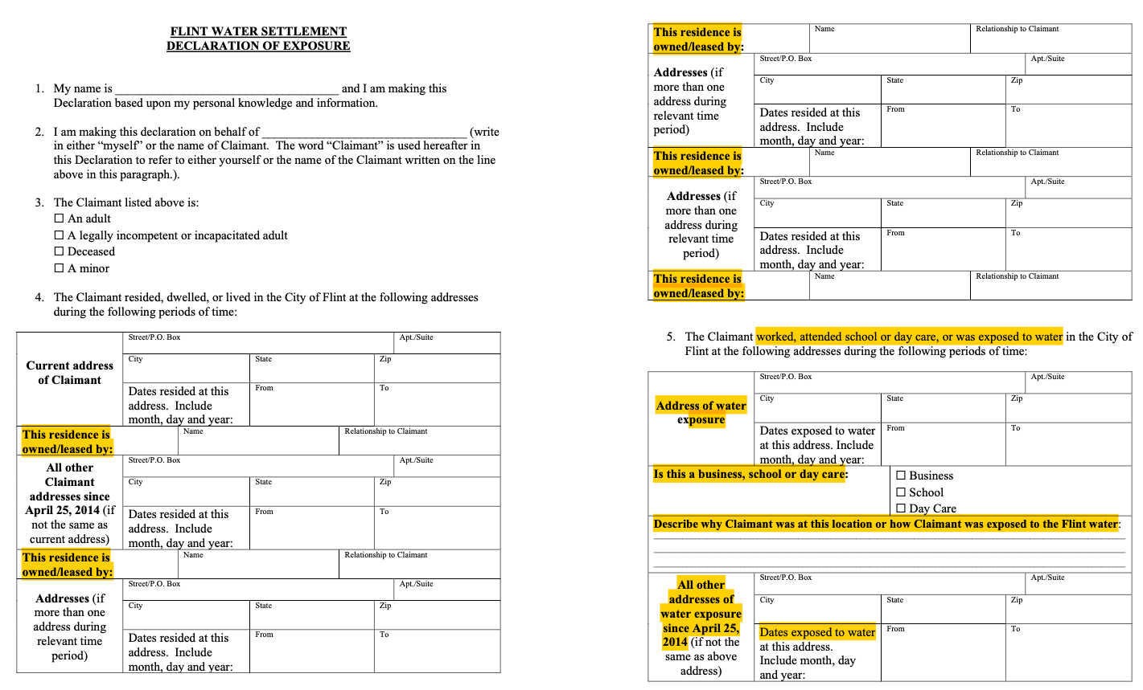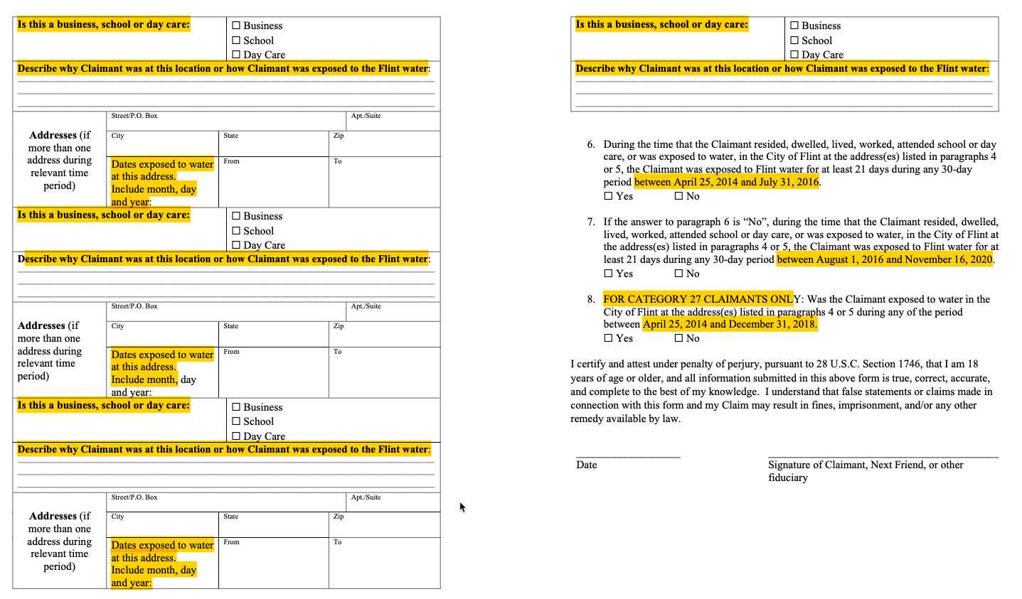

Real Property Owner/Renter or Business Owner Declaration
Complete this Declaration for each Claim Form in which Categories 28-30 are selected.
Complete one form for each Flint residence you lived in or business you owned going back to April 25, 2014.
Fill out the following information on the Real Property Owner/Renter or Business Owner Declaration Form:
- Your name.
- Address of the affected property.
- Name of business (if applicable).
- Names of all owners, lessees, or interested parties, including yourself, as well as their contact information, nature of interest, and percentage of interest.
- Names of all owners or interested parties of the business, including yourself, as well as their contact information, nature of interest, and percentage of interest.
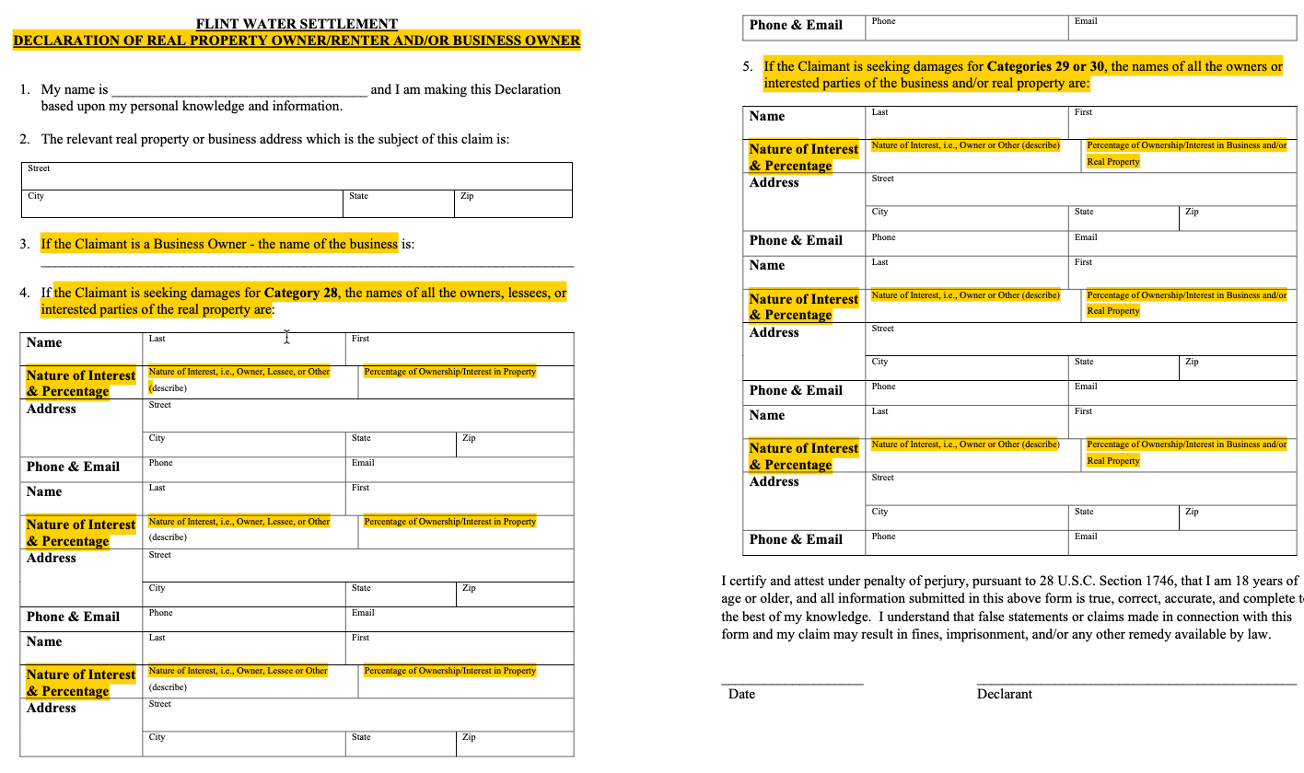

Business Interruption Declaration
Complete a Business Interruption Declaration for each Claim Form in which Categories 29-30 are selected.
Fill out the following information on the Business Interruption Declaration Form:
- Your name.
- Address of the affected real property/business.
- Name of business.
- Describe the property damage or business economic loss between April 25, 2014 and July 31, 2016.
- Describe your claimed amount of damages and how you determined the amount.
Note: Tax documents must be submitted in conjunction with this Declaration Form.

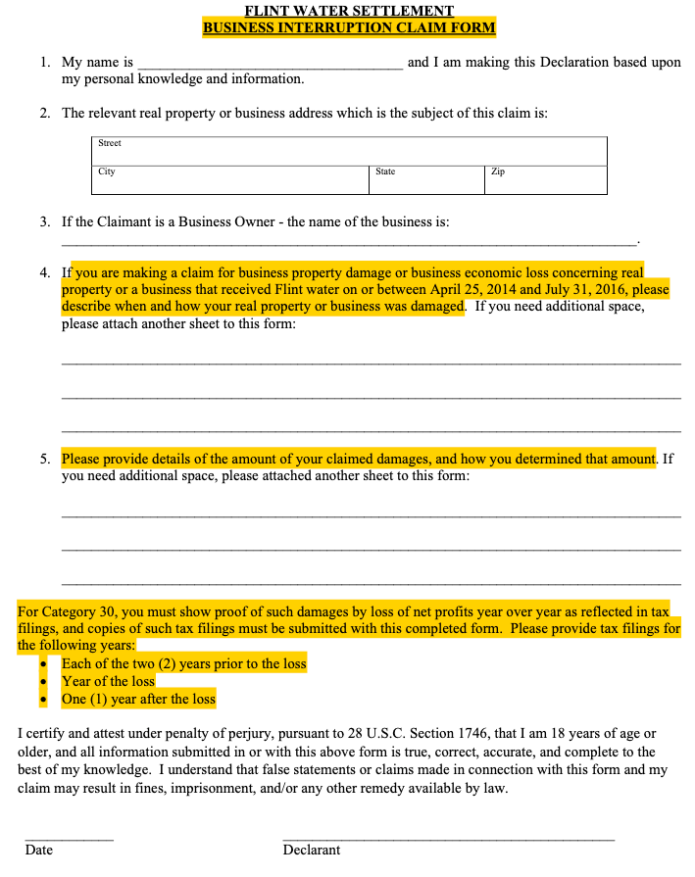

Release Form
- A standard release form is required to affirm no further legal action will be taken against the settlement defendants.
- Each claimant (or their representative) will need to sign a release in order to participate in the settlement.

Lien Disclosure Form

All claimants will fill out a lien disclosure related to the exposure and health care coverage.

Supporting Documentation

All Claimants who are filing an Exposure Declaration will provide one or more of the following supporting documents:
- Water bill in the Claimant’s name for each residence or business for which you lived/worked or paid a water bill between April 25, 2014 and November 2020;
Note: Please check your records or any online statements before requesting copies of water bills from the City.
OR
- School Record of attendance between April 2014 and November 2020, showing the address of the school and your name OR minor child’s name and address (showing Flint address of school and/or Claimant);
Note: If you and your minor child were both students, please submit records for all claimants separately.
OR
- Day Care Invoice dated between April 2014 and November 2020, showing the address of the Day Care and your child’s name (showing Flint address of day care location and/or Claimant);
OR
- Letter from employer verifying employment at a business in Flint between April 2014 and November 2020 with address (showing Flint address of place of employment and/or employee);
OR
- Check or pay stub for a business in Flint between April 2014 and November 2020 with address (showing Flint address of place of employment and/or employee);
OR
- Tax return showing each address where you lived in Flint between 2014 to 2020;
OR
- Deed to property located in Flint during the relevant category Exposure Period showing name of Claimant on deed;
OR
- Deed, a lease, or a mortgage statement for each residence or business for which you lived/worked or paid a water bill between 2014 to 2020;
OR
- Other document sufficient to reliably show address of Claimant’s exposure to Flint water during the relevant category Exposure Period. The Claims Administrator will follow up with you if necessary after their review of the documentation provided.​

Medical Records
Provide relevant medical records from your physician if you suffered from any of the following and were treated by a medical professional (for visits/treatments between April 25, 2014 and November of 2020):
- Preterm birth – if your child was born prior to 37 weeks or born weighing less than 5 lbs 8 oz;
- Miscarriage;
- A minor was formula fed with Flint water;
- Severe hypertension;
- Neuropathy;
- Stroke;
- Anemia;
- Renal insufficiency;
- Skin rashes or lesions;
- Hair loss;
- Respiratory problems;
- Pneumonia;
- Gastrointestinal conditions; or
- Legionnaire’s diagnosis.

Test Results
If you have had any of the following tests performed with documented results, please provide them to support your claim:
- Any cognitive deficiency tests (of a minor) from May 16, 2014 to date;
- Any blood lead level test results from May 16, 2014 and August 31, 2016;
- Any bone lead test results from May 16, 2014 to date;
- Any home water test results from May 16, 2014 to August 31, 2016.

All Claimants who are filing Real Property Owner/Renter or Business Owner/Interruption Declarations must provide at least one of the supporting documents listed below:

For Categories 28-30:
- Water bill in claimant’s or business name during exposure period
- Tax return during exposure period
- Deed, Lease, or Mortgage statement for Flint property with claimant’s name

Legal Authority to File for Another:
If you are completing forms on behalf of someone else:
- If you are completing forms on behalf of a minor child, please gather the minor’s birth certificate and any other documents showing guardianship or adoption, as applicable;
- If you are completing forms on behalf of a decedent, please gather the decedent’s death certificate and estate papers;
- If you are completing forms on behalf of a business, please gather the certificate of incorporation and tax records from 2012 to present.

